# AmpX ESP32 ME131 Modbus Webpage energy logger display

## Resources

* YouTube Videos
  + [BitBastelei #321 - WLAN-Stromzähler mit Modbus, ESP8266/Arduino und SDM120](https://youtu.be/zrT1bVjxHdk?si=vTnpDGPOjyQ8KHxr)
  + [Introduction to ESP32 Board - Getting Started ( Step by Step)](https://youtu.be/aLEKiGNfHZw?si=cEBbZJ7lwsmB8u_t)
  + [ESP32 Web Server - ESP32 Beginner's Guide](https://youtu.be/z-I-r3PX2lU?si=DNReXiJrhPtoxY0m)
  + [WiFiManager with ESP32 - Stop Hard-coding WiFi Credentials!](https://youtu.be/VnfX9YJbaU8?si=DxTSzrFakfAGw1hq)
  + [TUTORIAL: How to make MODBUS work with ESP32 - Arduino - RS485 - Part 1](https://youtu.be/NJAXs3T4NRg?si=tI0fwypxDUB6dKqu)
  + [ESP32 For Beginners Playlist by enjoy Mechtronics](https://www.youtube.com/playlist?list=PLlLe2PpVuiVJ7bdUtQHkXIlMzqxeOtrqd)
* Espressif
  + <http://esp32.net/>
* AZ-Delivery
  + ESP32 Dev Kit C V2, NodeMCU, ESP-32S
  + <https://www.az-delivery.de/en/products/esp32-developmentboard>
  + ESP-32 Dev Kit C V4, Dev Kit C V2
    - <https://www.az-delivery.de/en/products/esp-32-dev-kit-c-v4>
    - Node-32S in Arduino board selector.
* Amazon
  + <https://www.amazon.de/AZDelivery-NodeMCU-ESP-32S-Kit-Parent/dp/B09PLBPBCC?th=1>
* USB driver
  + <https://www.silabs.com/developer-tools/usb-to-uart-bridge-vcp-drivers?tab=downloads>
* Board Manager URL
  + <https://raw.githubusercontent.com/espressif/arduino-esp32/gh-pages/package_esp32_index.json>
* esp wroom 32, Node MCU, Datasheet
  + <https://www.espressif.com/sites/default/files/documentation/esp32-wroom-32_datasheet_en.pdf>
* MAX485 TTL To rs485
  + <https://robu.in/product/max485-ttl-rs485/>
* Example Project
  + <https://microdigisoft.com/esp32-with-modbus-rtu-rs485-protocol-using-arduino-ide/>
* Meter Serial Number: 33589392

## Design

* Version 1
  + ~~Hardware~~
    - ~~Use a ESP 32~~
    - ~~Use a RS485 to TTL converter board~~
    - ~~Use a USB power supply~~
  + ~~Software~~
    - ~~Read values from Modbus~~
      * ~~Serial Number~~
      * ~~Read Voltage on L1~~
    - ~~Display the values of one meter on serial monitor~~
* Version 1.1
  + ~~Read Voltage on L1, L2 and L3~~
  + ~~Read Current on L1, L2 and L3~~
  + ~~Move functions to separate library~~
* Version 1.2
  + Read values from Modbus
    - ~~Power In and Out on L1, L2 and L3, and Total~~
    - Energy In and Out on L1, L2 and L3, and Total
    - Display the values on serial monitor
* Version 1.3
  + Connect to local Wifi
* Version 1.4
  + Create a web page where the values can be read
* Version 2
  + Read data from multiple meters
  + Display data from other meters as well on webpage.
* Version 3
  + Use a power supply board
  + Build it into a ME131 slave housing
  + Link it all up
* Version 4
  + Log the data remotely to Arduino, Firebase, xx
* Version 5
  + Make the WiFi Username and password user configurable through WiFiMaster.

## Planning ideas

* Din raise based pne planning
* First Priorität is to get a working Version for the plot
* Hardware, Din raise enclosure, Power
* Have a v1 really basic but working.
* Minimum viable product
* Connect with rs485
* WiWi network and Password set in code
* Connect to API to log values
* Log every 5 m, So that one have at lease one reading every 15 minutes.
* Read 3 meters
* Log meter id
* Have 2 energy Gateways
  + Die rail, Android based
    - Just remote storage, no local
    - Uses Modbus RS485
  + Handheld, Raspberry Pi based
    - Also have local storage on SD Card
    - Uses Modbus TCP-IP

## Errors and Issues

### Error:

<https://forum.arduino.cc/t/cant-upload-code-to-esp32-please-help-typeerror-argument-of-type-nonetype-is-not-iterable/1274996/4>

**My Solution:**

1. Plug the USB cable to the board directly in to a USB port on the compute and not into a USB Hub
2. Disconnect the power supply from the ESP to the RS485 board
3. Move the pins away from 0, 2 and 4 and to 36 & 38
4. One of these three causes the error above…

### Error2:

Getting gibirish written to the serial port

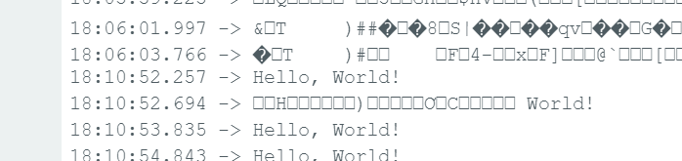

Solution

Wait a 2 seconds for the serial port to initialise before writing to it.

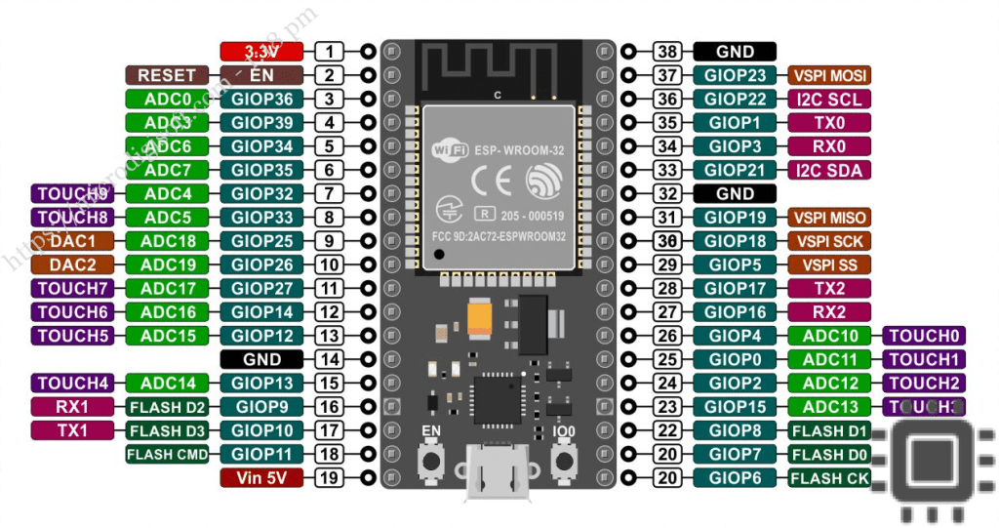

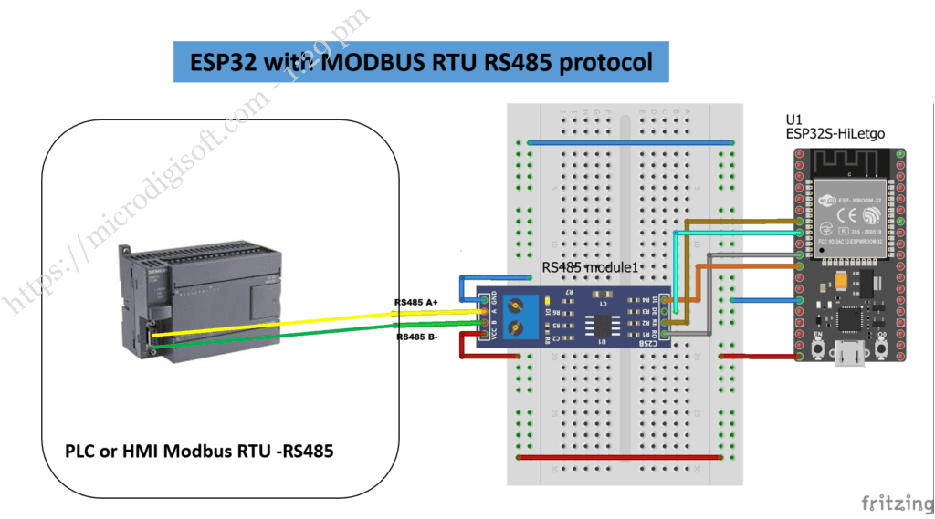

## Example microdigisoft

<https://microdigisoft.com/esp32-with-modbus-rtu-rs485-protocol-using-arduino-ide/#google_vignette>

**Open Library Manager**

Download and install ESpSoftwareSerial by Dirk Kaar, Peter Lerup.

## Example hackatronic

<https://hackatronic.com/max485-ttl-to-rs485-modbus-module-interfacing-with-esp32/>

## Meetings

### 2024-11-06

* Background
* Project overview.
* Weekly work sessions.
* Use Github
* Questions
  + Able to read Fritzing diagram?
  + IDE, VS Code or Arduino?
  + Ok to use software serial.
  + Best way to read multiple registers_
* Hardware requirements,
  + Ability to attach external arial.